Feature | UMA | NUMA
Memory access time | Uniform | Non-uniform
Memory location | Single shared memory | Distributed memory nodes
Scalability | Limited | Highly scalable
Example systems | Small SMP systems | Modern servers, data centers

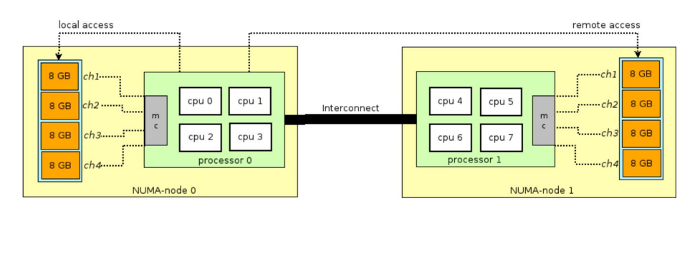NUMA-Aware Scheduling
NUMA-aware scheduling schedules a process on the CPU closest to the memory it uses most.
- OS tracks where process memory pages are allocated.
- Scheduler detects the NUMA node the process mostly accesses.
- Process is scheduled on CPU cores within the same NUMA node.
- This maximizes local memory access and minimizes remote memory access.
Local memory access → lower memory latency → higher throughput → improved performance and scalability.

